Functional Assessment of Sensory Status
of Children who are Deafblind

Developed by the
New Jersey Technical Assistance Project (N.J. TAP)
“Educational Resources & Support Services on behalf of Children with Deafblindness”

Jerry G. Petroff, Ph.D.
Cynthia L. Ruetsch, M.Ed.
Eva Scott, M.Ed.
A special thank you to our colleagues who assisted
in the revision and expansion of this assessment model.

 Juli Baumgarner, Project Coordinator, Hand in Hand in Hand: A Partnership Serving Families, Educators and Service Providers of Children and Youth who are Deaf-Blind (Pennsylvania)

 Betsy Bixler, Area Director, National Technical Assistance Consortium for Children and Young Adults who are Deaf-Blind (NTAC)

 Jeanne Gardier, Education Consultant, Hand in Hand in Hand: A Partnership Serving Families, Educators and Service Providers of Children and Youth who are Deaf-Blind (Pennsylvania)

 Peggy Lashbrook, Project Coordinator, Technical Assistance and Training for Service Providers of Children with Deafblindness in Delaware

 Betsy McGinnity, DB-LINK: The National Information Clearinghouse on Children who are Deaf-Blind

 Brian Touchette, Delaware Department of Education

 Nita Wynn, Administrative Assistant, Technical Assistance and Training for Service Providers of Children with Deafblindness in Delaware

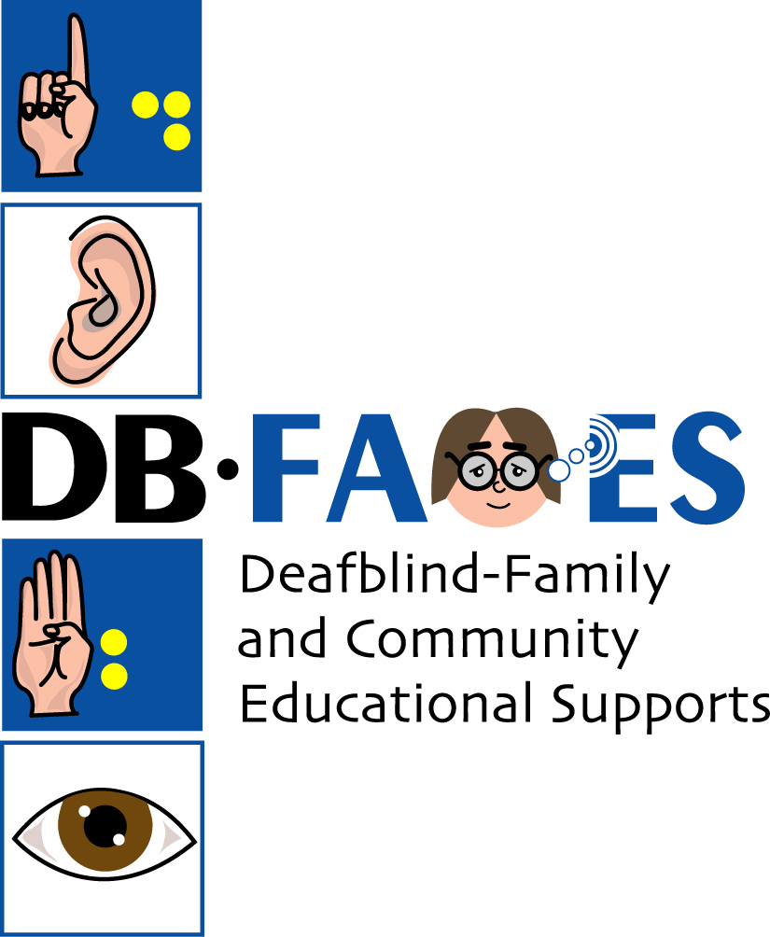

DB-FACES
“Promoting Quality Education & Successful Outcomes
for Students with Deafblindness”
dbfaces@tcnj.edu
(Formerly N.J. TAP)


8 N.J. TAP - This assessment guide was developed under a grant
from the US Department of Education (Grant #H025A20028)

Table of Contents

Introduction 4

Model for the Assessment of Sensory Functioning of Children who are Deafblind
Why use this Functional Assessment of Sensory Status in Children who are Deafblind? 5
Who should participate in this functional assessment process? 5
How do we complete the Functional Assessment of Sensory Status? 6
Part 1 – Sensory System: Formal Background Information 6
Part 2 – Sensory Functioning Profile 7
Part 3 – Educational Implications 8
How much time will it take to complete the functional assessment process? 8
Figure 1: Model for the Assessment of Sensory Function 10

Functional Assessment of Sensory Status – Checklists and Forms
Educationally-Oriented Questions to Ask the Audiologist 11
Educationally-Oriented Questions to Ask the Ophthalmologist 12
Sensory System Summary 13
Expectations and Impressions 15
Important Considerations for Observing Sensory Behavior 16
Sensory Functioning Observations 17
Profile of Sensory Functioning 23
Education Plan Review 25

INTRODUCTION

Infants, children, and youth with deafblindness represent a low incidence and extremely heterogeneous group with varying habilitative and educative needs. A critical component of program development for a child who is deafblind is the accurate assessment of her/his sensory functioning (primarily vision and hearing). Traditionally, parents, educators, and other specialists have considered vision and hearing impairments separate issues. As a result, educational programs often provide vision and hearing services (as well as PT, OT, etc,) separately thus requiring the child to “put it all together.” However, we now understand that our senses work together within a coordinated system to provide us with information about our environment. A systematic approach is required to assess a child’s overall sensory functioning.
Therefore, the development of this assessment tool is based on the belief that deafness and blindness are not separate impairments when encountered in an individual but are intertwined in their effect. The existence of impairment to both auditory and visual systems reflects a cumulative rather than additive effect that results in a unique/distinct disability - deafblindness. It is also recognized that a child’s sensory system may fluctuate over time, environmental conditions, and people (i.e., the child’s vision or hearing may function more or less optimally under different variables). Hence, a conceptual model of sensory functioning assessment for children who are deafblind has been developed (see Figure 1 on page 10). This model includes an evaluation protocol to facilitate ongoing functional assessment of the child’s sensory system and a tool to review the findings within the context of the child’s current education plan (IFSP/IEP). The Functional Assessment of Sensory Status in Children who are Deafblind has been designed for use by teachers, paraprofessionals, parents, and other team members, in collaboration with deafblind (and other sensory) specialists. This functional assessment includes three essential parts (Part 1 - Sensory System: Formal Background Information; Part 2 - Sensory Functioning Profile; and Part 3 - Educational Implications) that will ensure a comprehensive approach to educational planning for the child who is deafblind.

Model for the Assessment of Sensory Functioning
of Children who are Deafblind

Why use this Functional Assessment of Sensory Status in Children who are Deafblind?

- To gather and document information regarding a child’s sensory system with a focus on the primary senses of vision and hearing;

- To gain a better understanding of medical reports regarding vision and hearing;

- To gain a better understanding of the effects of deafblindness (visual & auditory impairments) on human development and functioning;

- To foster communication among team members – specifically to share individuals’ impressions of the child’s sensory status and identify discrepancies between the medical reports and the team’s impressions;

- To facilitate a systematic approach to observation through the use of a specific data collection tool;

- To synthesize the medical and observational data to attain the best understanding of the child’s sensory status; and

- To ensure appropriate accommodations and supports (regarding issues of deafblindness) are infused in the child’s education program/daily activities.

Who should participate in this functional assessment process?

- Parents, teachers, and paraprofessionals (and any other professionals who know the child) in collaboration with specialists who provide services to children who are deafblind (i.e., Deafblind Consultants, Teachers of the Blind/Visually Impaired, Teachers of the Deaf, medical professionals, etc.).

Note: It may be helpful to identify one team member to coordinate the assessment process to ensure (1) full participation from all team members and (2) accurate completion of all documents.

How do we complete the Functional Assessment of Sensory Status?

The Functional Assessment of Sensory Status includes three parts. Although it is divided into parts, it should not be considered a linear process. Each part of the functional assessment is interrelated and should be revisited and updated as information changes or as new information is obtained.

Part 1 - Sensory System: Formal Background Information

- Collect background information from relevant professionals/physicians. Use the Educationally-Oriented Questions to Ask the Audiologist (see page 11), and Educationally-Oriented Questions to Ask the Ophthalmologist (see page 12) forms to help guide discussions during appointments/evaluations. Although the end result will be a profile of the child’s overall sensory functioning, it is critical that we understand the status of the individual sensory systems (i.e., auditory and visual). Later in the process this information will be put together to create a comprehensive sensory profile.
- Complete the Sensory System Summary form (see pages 13 - 14) to summarize the information collected from the various professionals/physicians. The Sensory System Summary offers a place to document critical details regarding the child’s visual and hearing impairments (including use of glasses, hearing aids, etc.) as well as other medical factors that may impact the child’s sensory functioning (e.g., medications, seizures, etc.). Keep this document as a quick reference for use at future planning meetings.

Part 2 - Sensory Functioning Profile

- Complete the Expectations and Impressions form (see page 15). After gathering and reviewing the medical information think about the Expected Sensory Functioning for the child. Write a brief description of your best understanding of the medical information (i.e., what you expect the child to see and hear).
- Next, record your Current Impressions (see page 15). Write a brief description of the child’s sensory functioning as you perceive it. This section should capture your “gut” feelings based upon your daily interactions with the child. This is an important step since teachers, paraprofessionals and parents often report different impressions of the child’s sensory functioning (what the child sees and hears). Therefore, each team member’s perspective should be discussed and incorporated into the assessment.
- Now record any Discrepancies (see page 15). Compare the medical information with your current impressions and document any conflicts or differences (e.g., eye reports indicate that the child has a severe acuity problem and needs material presented close up, however, the child can see her/his favorite toy from across the room). This step should help you (1) articulate any questions or concerns you may have regarding the child’s sensory functioning and (2) focus your observations.
- Make some observations and record your findings on the Sensory Functioning Observations form (see pages 17 - 22). Have several team members participate in the observation process. This will allow for a variety of observer perspectives and observation times and settings. To help guide this process you may want to begin by reviewing the fact sheet: Important Considerations for Observing Sensory Behavior (see page 16).
- After the observations are complete, meet as a team and review your findings. Compare each person’s findings and summarize them on the Profile of Sensory Functioning form (see pages 23 - 24). Keep this form as a quick reference regarding the optimal environment and conditions for the child with deafblindness.

Part 3 - Educational Implications

- Once you’ve summarized your observations regarding the child’s sensory functioning, compare your findings with the child’s current education plan (IFSP/IEP goals, objectives and activities). Document this information on the Education Plan Review form (see pages 25 - 26). For each focus area, describe (1) those areas being addressed optimally, (2) those areas that need improvement; and (3) strategies for change.
- Finally, incorporate the strategies for change into the child’s current program and/or within future IFSP/IEPs.
- REMEMBER…providing appropriate supports for a child who is deafblind requires up-to-date information regarding her/his sensory status. Therefore, the Profile of Sensory Functioning should be reviewed regularly and the observations and summaries repeated and revised as needed.

How much time will it take to complete the functional assessment process?

- The amount of time to complete this assessment will vary based on team members’ knowledge of the child, available records, etc. It is a process and therefore will be completed over a period of time. Additionally, this information should be updated on an ongoing basis to ensure optimal program development for the child who is deafblind. Below outlines an approximate timeframe to assist with your planning.

Part 1 – Sensory System: Formal Background Information: Completion time depends on the availability of the child’s background/medical information (e.g., audiological/ophthalmological reports, medication information, etc.).

Part 1 Forms:
Educationally-Oriented Questions to Ask the Audiologist
Educationally-Oriented Questions to Ask the Ophthalmologist
Sensory System Summary

Part 2 – Sensory Functioning Profile: Expectations and impressions regarding the child’s sensory status can be documented in a rather short period of time and should be completed by each team member. Observations should also be conducted by individual team members and should take place over the course of several class periods to ensure data reflects a variety of settings and activities. Completion of the sensory functioning profile requires one team meeting.

Part 2 Forms:
Expectations and Impressions
Sensory Functioning Observations
Profile of Sensory Functioning

Part 3 – Educational Implications: Initial review of the child’s education plan, including identification of new strategies and supports, could take between one and two team meetings to complete.

Part 3 Form:
Education Plan Review

Figure 1 Model for the Assessment of Sensory Function

Educationally-Oriented Questions to Ask the Audiologist

1. What type of hearing loss does the child have (conductive, sensorineural, mixed)?

2. Is the hearing loss unilateral, bilateral, symmetrical or bilateral asymmetrical?

3. What degree of hearing loss does the child have (mild, moderate, severe, profound)?

4. What is the cause of the hearing loss?

5. How long has the child had the hearing loss? Is it acquired or congenital?

6. Is the hearing loss fluctuating, stable, or progressive?

7. What types of audiological tests were completed? Should any other tests be done? If yes, which ones?

8. Are any medical interventions recommended (e.g., medication, surgery, Cochlear Implant, etc.)? What type of physician should provide this care?

9. Is amplification appropriate? If yes, what type of device would be most beneficial?

a.) Personal (e.g., ear-level, body aid, binaural, monaural, bone-conduction, etc.)
b.) Environmental

10. How does this type of hearing loss typically effect the child’s speech and language development?

Educationally-Oriented Questions to ask the Ophthalmologist

1. What is the cause of the visual impairment?

2. Is any special treatment required? Is so, what is the general nature of the treatment?

3. Is the visual impairment likely to get worse, better, or remain the same?

4. What symptoms would indicate a need for re-examination?

5. Should any restrictions be placed on the child’s activities?

6. Should the child wear glasses or contact lenses? If so, under what circumstances?

7. If it was not possible to do a visual acuity measure, what is your opinion regarding what the student sees?

8. Are the child’s focusing ability, tracking, and eye muscle balance adequate? If not, please describe.

9. If the child’s visual field was not testable, what is your opinion regarding the child’s field of vision?

10. Please describe the object/material size and distances that are optimal for the child?

11. What lighting conditions would be optimal for the child’s visual functioning?

12. Are there any additional recommendations for the child regarding the use of vision in the learning situation?
Sensory System Summary

Completed by:

Etiology (Medical Diagnosis):

Primary Sensory Status
Vision | Hearing
 Date of last ophthalmological  __________________________________   Ophthalmologist’s name  __________________________________   Cause of vision loss  __________________________________   Near vision acuity  __________________________________   Distance vision acuity  __________________________________   Visual fields ________________________   Wears glasses/correction (yes / no)  Refraction:_________________________   Wears contact lenses (yes / no)   Uses low vision device(s) (yes / no)   Uses prosthetic device(s) (yes / no)   Other interventions/treatments/ medications  __________________________________  __________________________________ |  Date of last audiological  __________________________________   Audiologist’s name  __________________________________   Cause of hearing impairment  __________________________________   Type & degree (in dB) of hearing loss  __________________________________   Type(s) of hearing test(s) administered  __________________________________   Uses personal/environmental hearing devices (yes / no)   Has Cochlear Implant (yes / no)   Assistive Listening Device has been recommended? (yes / no)   Other interventions/treatments/ medications  __________________________________  __________________________________

Other Sensory Issues (taction, olfactory, gustatory, proprioception/kinesthetic/vestibular)

Medically linked factors that could impact sensory functioning (e.g., medication, seizures, etc.)

Expectations and Impressions

Expected Sensory Functioning

Given the information included in the Sensory System Summary, what can you expect the child to see and hear? What is your best understanding of the medical reports? Please write a brief description below.

Current Impressions  Please write a brief description of the child’s sensory functioning as you perceive it. | Discrepancies  Compare the medical information with your current impressions. Document any conflicts and/or differences between the two.

IMPORTANT CONSIDERATIONS FOR
OBSERVING SENSORY BEHAVIOR

 Be open minded when observing the child. Have some expectations, but be alert to the unexpected.

 Remember… one cannot be an observer and a participant at the same time.

 Have a plan and some idea of what you are looking for AND keep a written record of the observation.

 Different types of data can be collected. Consider the type(s) of data you want to record. The following are some examples that would be helpful for gathering information regarding a child’s sensory status.

 Checklist or Guided Observation/question and answer format (e.g., Sensory Functioning Observations form)

 Frequency Recording: measures the number of times the child engages in a specific behavior within a set period of time.

 Duration Recording: measures the total amount of time the child spends engaging in a specific behavior.

Note: When recording frequency or duration of sensory behavior, one must also make note of the setting and conditions in which the behaviors took place (e.g., location, objects, person(s), activity, etc.).

 Engage different observers to build inter-observer reliability.

 Consider videotaping… to verify what was observed, to increase the number of observers, and to decrease distraction and intrusion.

 Consider all forms of sensory information (direct and indirect) presented during a given interaction.

- Observations of sensory behavior should represent a variety of conditions (e.g., setting, people, materials, etc.) AND should include both routine and novel activities.
Sensory Functioning Observations

Completed by:

Setting: | Time of Day:
Other individuals in the area: | Other environmental feature(s):

 What is the best way to approach the child?

 How does the child exhibit attending behavior or engagement?

 During activities and/or interactions with others, how does the child focus, attend, and engage?

 Where does the child appear to prefer placement of material or position(s) of participants (him/herself included)?

 Interactions with people, objects, and materials…

 When presented with a familiar object, how does the child interact?

 When presented with a novel object, how does the child interact?

 What are the most successful approaches when presenting people, objects and/or materials? Please describe.

 How does the child initiate interactions with others?

 How does the child sustain interactions with others?

 Exploring the environment…

 How does the child explore their immediate environment?

 How does the child initiate play or exploration with objects?

 How does the child sustain exploration with objects?

 Environmental conditions…

 What are the preferred attributes/characteristics of…

Objects:

Materials:

People:

 In which environment(s) does the child function optimally? Why do you think that?

 Describe the optimal environment. Indicate what combinations of the following create the best access to the environment.

Setting  (Location/People) | Visual Input | Auditory Input | Tactile Input

 Preferences…

Movement:

 What types of movement activities does the child like (e.g., riding in a car, swinging, riding in a stroller)?; How do you know?; What are the common attributes among the activities?

 What types of movement activities does the child dislike?; How do you know?; What are the common attributes among the activities?

 What types of movement activities are “neutral”?; How do you know?; What are the common attributes among these activities?

Objects and Activities:

 What are the child’s favorite activities and objects?; How do you know?; What are the common attributes among these things?

 What are the child’s least favorite activities and objects?; How do you know?; What are the common attributes among these things?

 What are some “neutral” activities and objects?; How do you know?; What are the common attributes among these things?

People:

 Who are the people the child is comfortable with?; How do you know?

 Who are the people the child is not comfortable with?; How do you know?

 How does the child achieve homeostasis?; What behaviors does the child exhibit? Please describe the situation.

 How much stimulation (e.g., light, size, number, complexity) is too much?; How does the child communicate this?; What does the child do to “turn off” or filter out stimuli?

 How does the child alert/react to environmental incidents (e.g., airplane flying overhead, smoke alarm, changes in lighting, etc.)?

 What are the most favorable strategies for introducing changes/transitions (e.g., position, location, activity, environmental condition)?

 How does the environment effect the child’s mobility?

 Describe the child’s typical sleeping patterns. Has any change in sleeping patterns occurred? If so, how does it impact on the child’s functioning?

 Do other conditions (e.g., weather, illness, living arrangements, family events, etc.) effect the child’s functioning? If yes, how?

 Additional Comments/Information
Profile of Sensory Functioning

Completed by:

Based on the information from the Sensory System Summary, Expectations and Impressions, and Sensory Functioning Observation forms, provide a brief description/summary for each of the following:

The optimal environmental conditions (list specific attributes within the environment) for ________: | The best strategies for approaching, interacting, and transitioning ________:
Methods and approaches ________ uses to explore the environment (including people, places and objects): | ________’s preferences (including materials, attributes, places and people):

Ways to assist _____ in achieving homeostasis (i.e., replace self-stimulatory behaviors): | Ways that ______ indicates a need for reduced sensory stimuli:
Assistive Technology conditions & needs: | Things to avoid:
Medical factors that influence sensory functioning: | Other useful information:

Education Plan Review

Completed by:

Review the child’s current education plan (IFSP/IEP) and compare the current goals, objectives, and activities with the information you documented on the Profile of Sensory Functioning form. For each of the focus areas, indicate (1) those areas that are being addressed optimally, and how; (2) those areas that need improvement; and (3) strategies for change.

Sensory Profile Focus Areas | Areas Addressed Optimally; How are they being addressed? | Areas that Need Improvement | Strategies for Change
Optimal environmental conditions

The best strategies for:

 approaching
 interacting
 transitioning

Methods and approaches used to explore the environment (including people, places and objects)

Sensory Profile Focus Areas | Areas Addressed Optimally; How are they being addressed? | Areas that Need Improvement | Strategies for Change
Assistive Technology
conditions and needs

Ways to assist in achieving homeostasis (i.e., replace self-stimulatory behaviors)

Ways to indicate need for
reduced sensory stimuli

Preferences (including materials, attributes, places & people)

Things to avoid

